- 大标题，正中间。
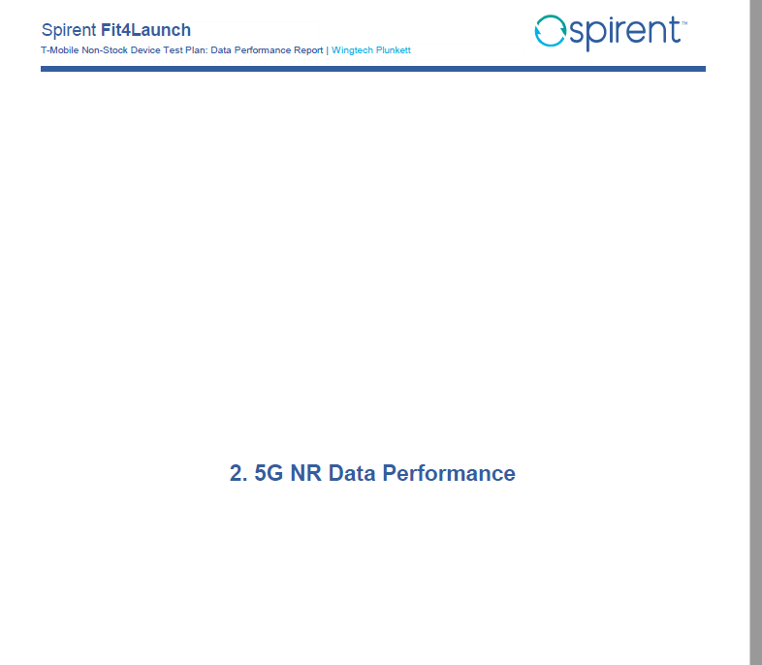
- Device Performance Comparison to Reference- 5G NR
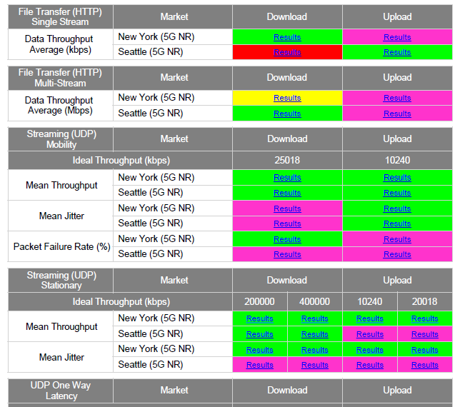

- Summary of Failed Test Cases
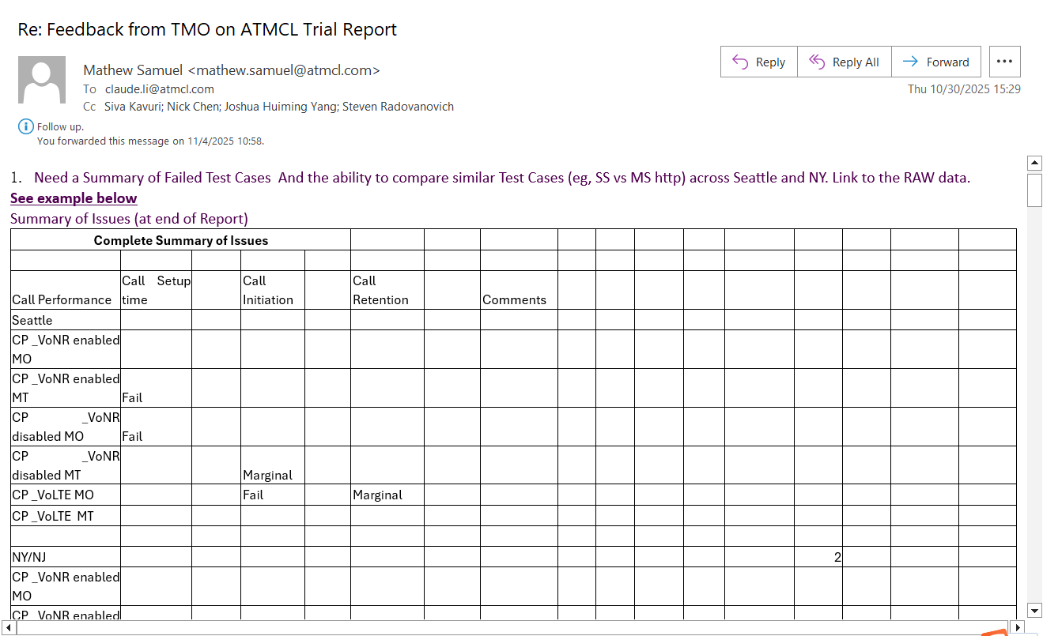

- 各项测试的名称大标题 测试名称如下
HTTP Single Stream test – 5G NR
HTTP Multi Stream test- 5G NR
UDP test -5G NR
PING test-5G NR
Web browser test – 5G NR
Play-store app download test – 5G NR
Mobile hot spot test – Seattle only- 5G NR
Mobility test – 5G NR
- 5G Auto Data Test Drive
- 5G Auto Data Test MHS Drive
VoNR MRAB Stationary test - 5G NR

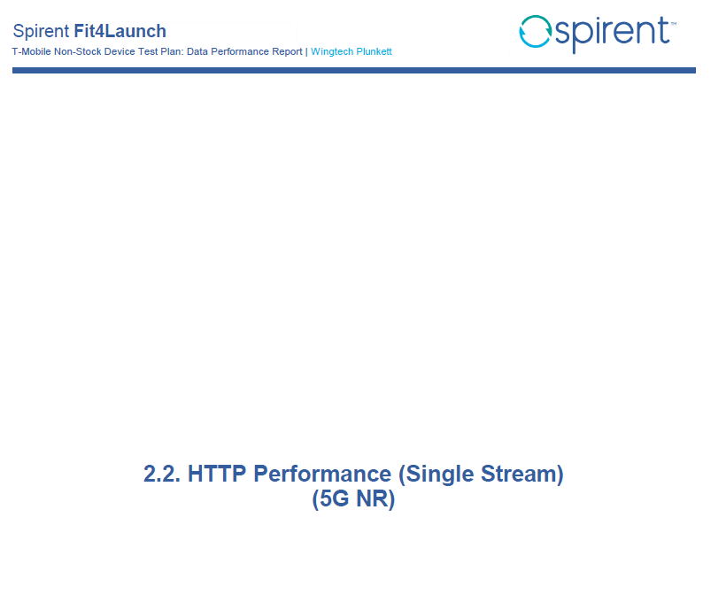
5 .各项测试 detail
Example：
HTTP Single Stream test – 5G NR
5G Auto Mode – Overall Results summary
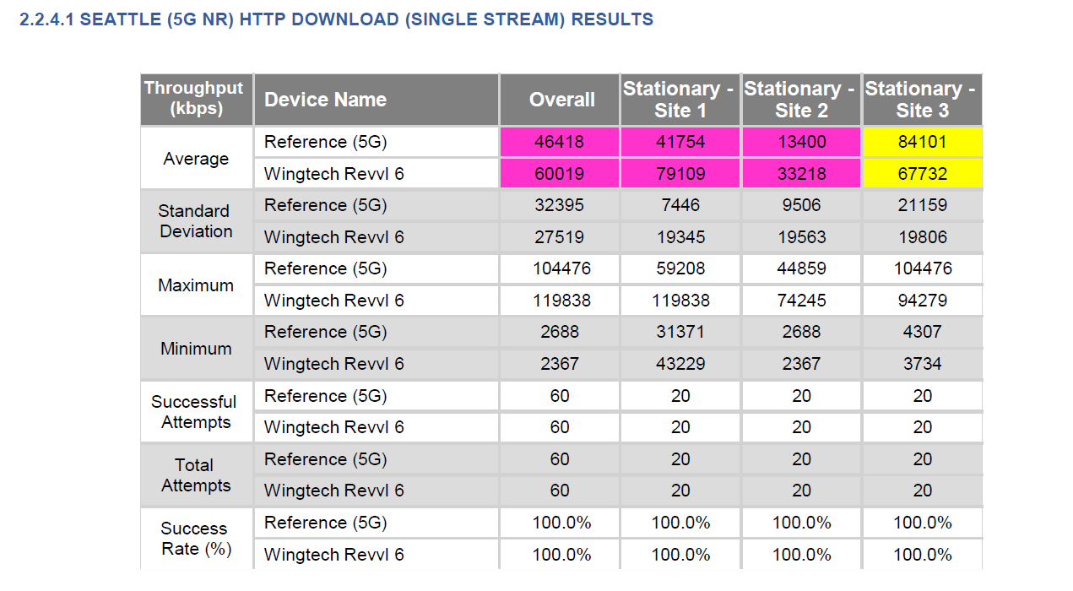

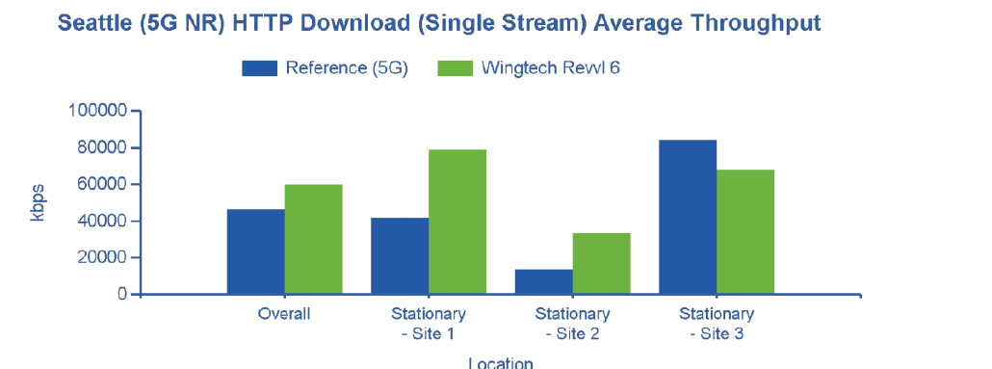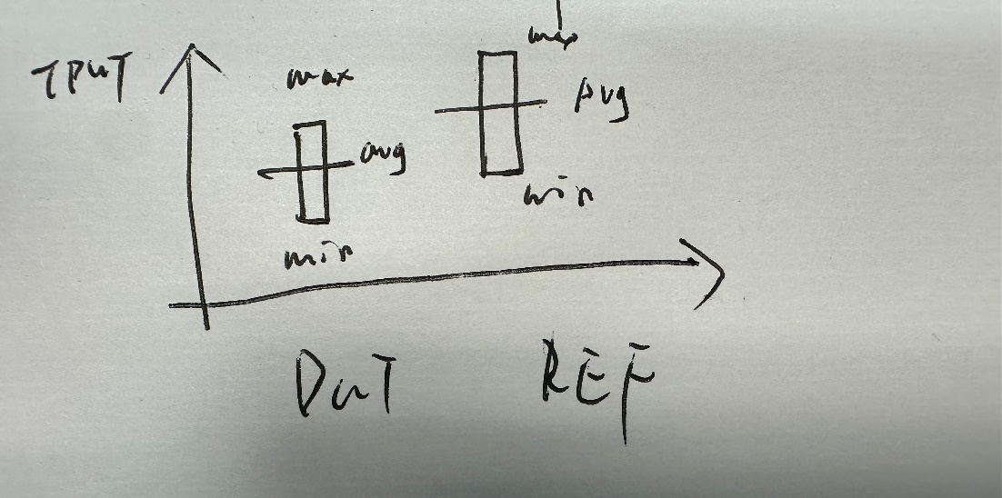
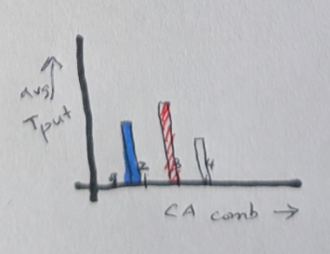

APPENDIX A
-
KPI Pass-Fail Criteria
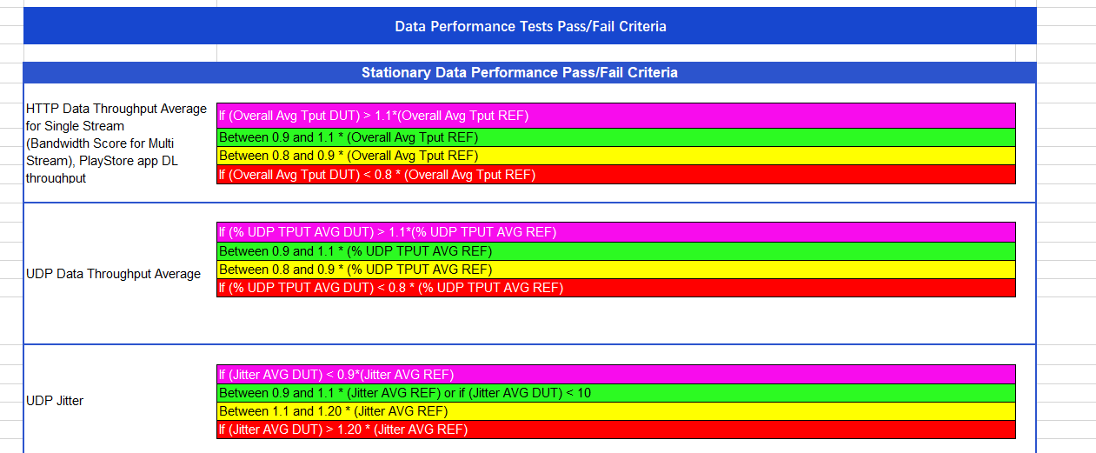
APPENDIX B-TEST METHOD
APPENDIX C- about us

